At the heart of the solution lies communication. The aim, contained within an encompassing ring highlights outcomes of innovation, engagement, purpose and vision.

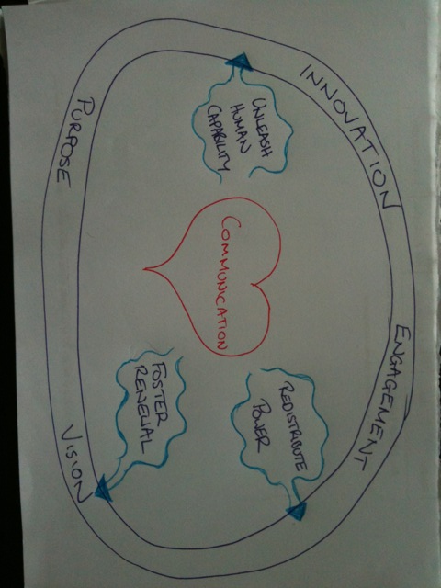

The catalysts are operating concepts including hashtags, <140 characters, open access (within the organisation), red flags, brutal facts, likes and dislikes. These catalysts inject life into the ideas of redistribution of power, fostering renewal and unleashing human capability to achieve outcomes that expand to include ideas and solutions.

