**Platform for Global Health, HANA Use Case – SAP Public Sector**

**Background**

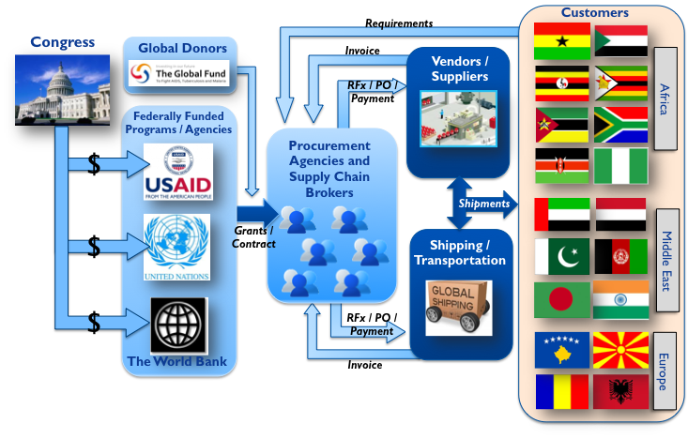Countries around the world apply for international aid to improve in-country health systems. On April 8, The Global Fund, which fights AIDS, tuberculosis, and malaria, requested [$15 billion dollars](http://www.theglobalfund.org/en/mediacenter/newsreleases/2013-04-08_Global_Fund_Targets_USD_15_Billion_to_Effectively_Fight_AIDS_TB_and_Malaria/) for 2014-2016, and earlier this year, the Harvard School of Public Health called the President’s Emergency Plan for AIDS Relief (PEPFAR) “[The Largest Public Health Endeavor in History](http://harvardmagazine.com/2013/01/harvard-pepfar).” Since 2003, the U.S. PEPFAR program has committed more than $18 billion dollars to deliver medicine to treat and prevent HIV/AIDS.

With multiple donor supply chains now in place, country governments and global donors are searching for a more collaborative software environment to transact business. SAP Platform for Global Health will connect the country officials, civil society, multilateral and bilateral partners, and the private sector in a collaborative global health software environment as described in the [PEPFAR Blueprint: Creating an AIDS-free Generation](http://www.pepfar.gov/documents/organization/201386.pdf). Without collaborative software, too much time is wasted in funding proposals, paper approvals, lost email, client change orders, and overall poor data visibility for clients, suppliers, and donors. With the SAP Business Suite, SRM/PPS, and SAP HANA / AWS, the Platform for Global Health is in a position to automate the forecasting, procurement, and transportation management to transform global health forever.

**Platform for Global Health Use Case**

The current challenge is each country or global donor does not have the knowledge or risk appetite to build its own ERP solution. Instead, SAP Platform for Global Health will build a global health destination portal to provide a low cost entry for the best procurement and transportation services in the world. Once setup, the global health marketplace will serve as a SaaS. Various customers will subscribe to this solution. SAP will earn license revenue as the environment serves as the global destination for global health procurement. Furthermore, countries will seek to deploy other SAP tools, such as warehouse management, mobile devices, and analytic apps. These tools will be available through this platform as a SaaS model. We will build it, and stakeholders will be willing to pay for the use of the platform and network. The risk is that the market will quickly evolve and an open source tool will fill this gap.

While the U.S. funded the initial emergency phase for the development of a global procurement solution, private industry will manage and sustain this global health endeavor. Moreover, countries are expected to take more ownership of their in-country health systems. With the right SAP provided tools, country ownership is now possible at a fraction of the cost under a SAP SaaS model than multiple donors funding ad hoc application solutions. All in all, it's about SAP powering the platform to transform global health and in-country health systems.

**Solution Overview: Core Capabilities**

Leveraging a SAP HANA platform as the foundation for this solution will enable a global supply chain to deliver medical supplies to countries in need. SAP HANA will provide a collaborative platform that enables:

* 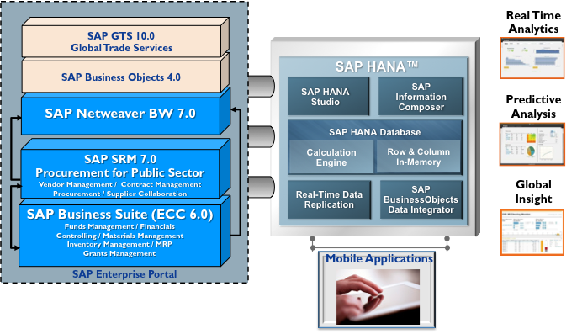US Government agencies to provide and track program funding,
* Contracted buyers and brokers to efficiently manage a global supply chain optimizing resources, and delivering product quicker and at a better value
* Vendors to provide on-line self service
* Big data analytics and monitoring of key performance indicators
* Predicative analysis to optimize the supply chain and reduce lead times and increase quality of services
* 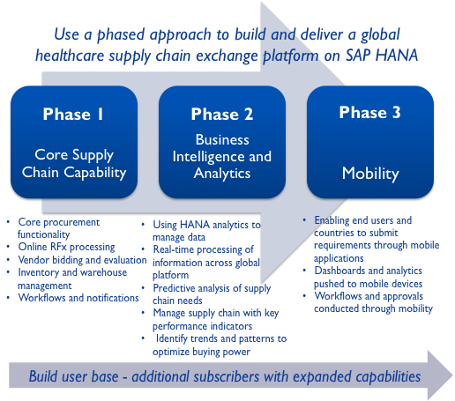Increase buying power and spending trends with more visibility and access to data
* Real-time data monitoring of status of orders and delivery anywhere in the world
* A Platform to deliver mobile applications to buyers, suppliers, customers, and granting agencies that will streamline and optimize the supply chain process.

This vision will be enabled using the SAP Business Suite, Supplier Relationship Management with Procurement for Public Sector, SAP Enterprise Portals, Business Intelligence, and Business Objects all on the SAP HANA Platform.

**Summary / Conclusion**

Our SAP Platform for Global Health transforms global donor grants, procurement, and international development.  The platform encourages collaboration between all the global and local stakeholders, including government officials and private industry.  With these gains in efficiency and aid effectiveness, developing countries stay healthier and have stronger economies.  Developing countries now have the SAP tools to own and facilitate their own destiny.  HANA powers the real-time access and predictive analysis for a massive big data global health databank.  This is the Platform for Global Health.